Guided Capstone Project Report

1. **Objective:**

To determine if Big Mountain Resort (Montana) can increase daily ski lift ticket prices based on market comparisons and relative positioning

1. **Assumptions and Exclusions:**

*B1. Key Assumptions 🡪*

* Prices are set by a free market (consumer demand versus available supply)
* State population data was extracted from Wikipedia.org; after inspection, the data appears to be consistent with census data
* I don’t account for annualized visitor data or operating costs for each resort as that data wasn’t available
* I don’t account for demographic differences and household gross income differences between states/regions

*B2. Key Exclusions 🡪*

* Dropped rows of resort data where the ticket price was not included after ensuring the ancillary data was not relevant for this analysis
* Dropped the weekday prices column and centralized the analysis around the weekend prices, as Montana’s weekday/weekend prices are the same for all resorts
* After the holistic inspection of the dataset, it made sense to drop some numerical data deemed non-essential (no statistical influence) or incomplete for this analysis (e.g. FastEight)

1. **High-level steps for the Analysis:**

*C1. Data Collection and Wrangling 🡪*

* Imported two separate datasets and inspected values
  + 1) comprehensive US ski resort dataset (ski_data, **Figs. A-C**) that incorporated 26 different, independent features
  + 2) state population and acreage data (state_summary, **Fig. D**) in order to account for density metrics
* Accounted for missing values and erroneous/extreme data points after visualizing distributions of each variable

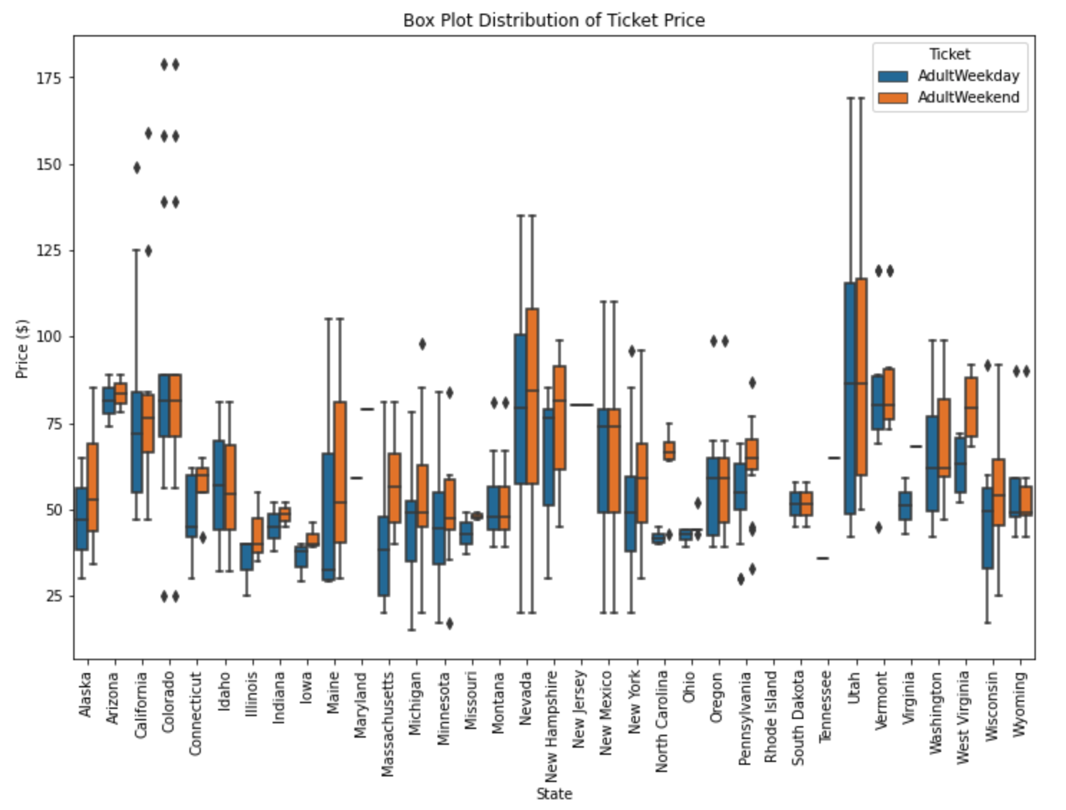

**Fig. A – Ticket Price per State Box Plot (dependent variable) Fig. B – Statistical Summary of all Numerical Data for the Ski_Data Dataset**

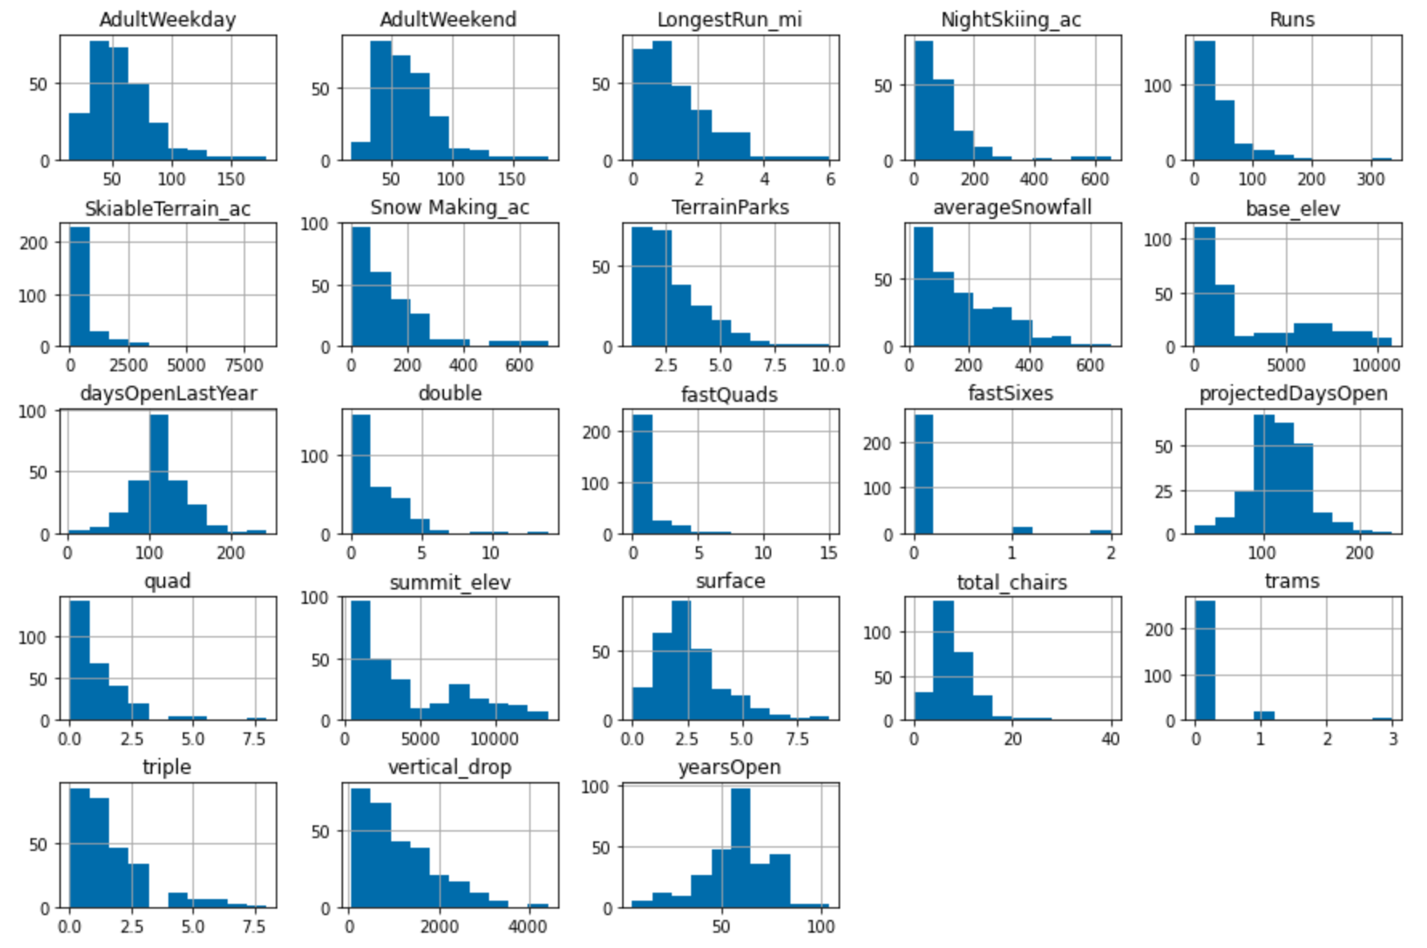

**Fig C – Distributions of all Variables within the Ski_Data Dataset**

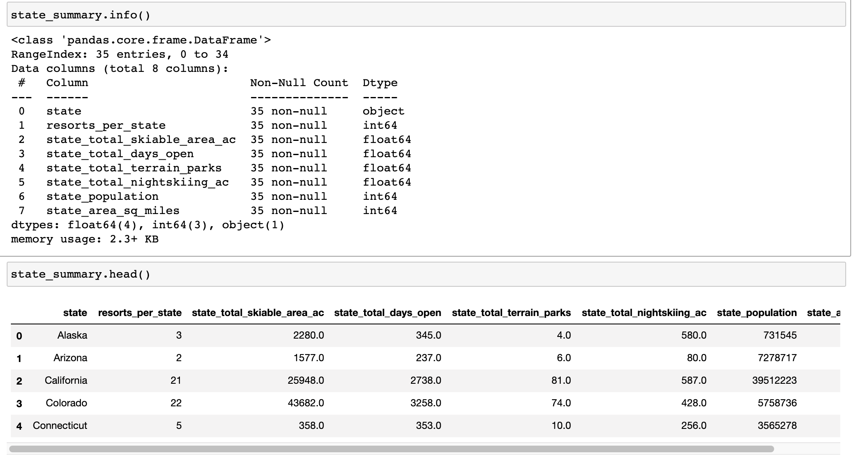

**Fig. D – State_Summary Dataset Excerpt**

*C2. Exploratory Data Analysis 🡪*

* Prior to combining that state_summary and ski_resort datasets, it was necessary to complete a parts component analysis (PCA) on the state_summary dataset in order to determine which states demonstrate similar statistical characteristics when considering population and density metrics
  + As you will see below, we have some clustering in the bottom left quadrant with dispersion becoming more pronounced as you move to the right and up
  + This step prompts additional questions regarding the outliers (New York, Vermont, New Hampshire, Colorado)
  + PC1 and PC2 account for ~80% of the statistical variance when comparing state-level data

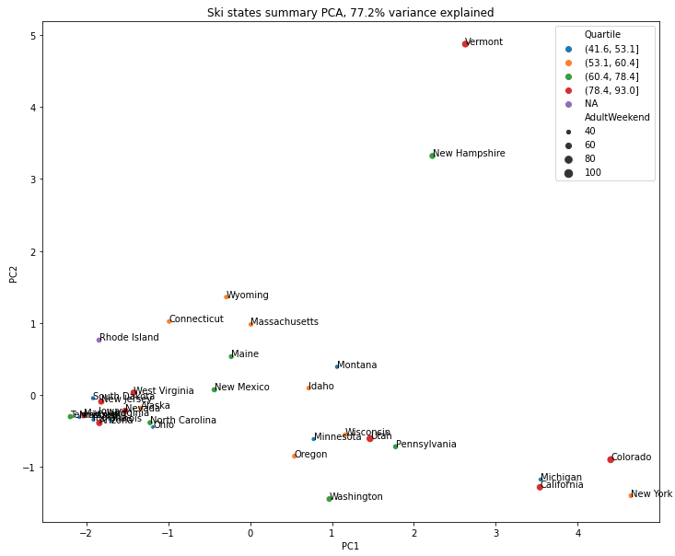

**Fig. E – PCA analysis of state_summary data**

* After inspecting the data more closely, it appears as though the resorts_per_100ksq_mile and resorts_per_100kcapita are the features most influencing this PCA analysis
  + Vermont and New Hampshire have large values for resorts_per_100ksq_mile in absolute terms and Vermont also has a large value for resorts_per_100kcapita while New York’s value is low
* Based on the PCA analysis, it doesn’t make sense to treat certain states/regions differently
* Now that we have a more robust dataset, it is time to understand the correlation between all features and determine if multicollinearity is an issue; **Fig. F** showcases the correlation matrix for all features/variables

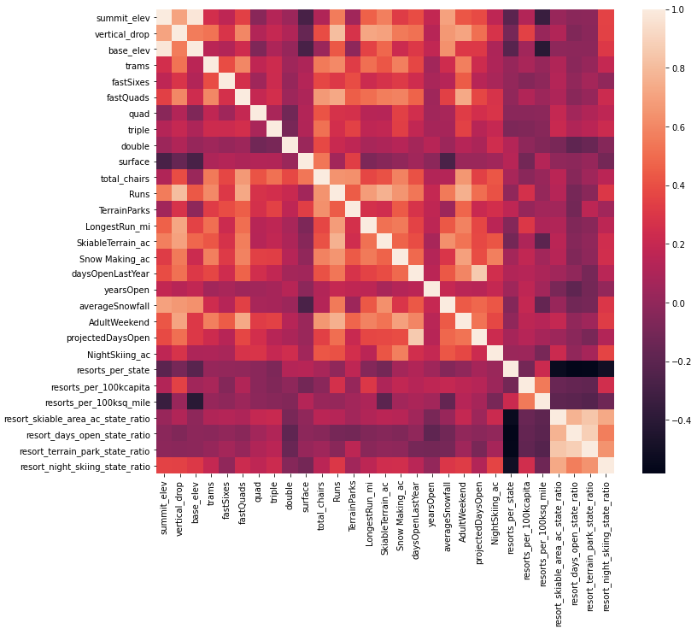

**Fig. F – Correlation Matrix for all Features**

* Based on the above matrix, the variables that are most positively correlated with ticket price are: vertical_drop, fastQuads, runs, total_chairs and snow_making; it is important to note that correlation doesn’t necessarily mean causation

*C3. Preprocessing, Training and Optimizing the Predictive Models 🡪*

* Before building and training, I needed to compartmentalize the data
  + I split the ski_resort dataset into training (70%) and testing (30%) datasets and imputed missing values with the median of each feature
  + This training/testing partition was necessary to limit overfitting and increase the accuracy of my models
  + The test dataset was only used after the initial model was trained, refined and optimized using the training dataset
  + Key metrics for determining accuracy and relevance/performance of each model:
    - Coefficient of determination (Squared)
    - Mean absolute error (MAE)
    - Mean squared error (MSE)
* Initially, I built a simple linear regression model
  + Cross-validation and SelectBestK techniques were used to optimize the linear regression model
  + **Fig. G** showcases the k scores; from the graph we can see that the model is optimal when considering the 8 most influential features; beyond this, the model begins to become erratic and overfitting is a real problem

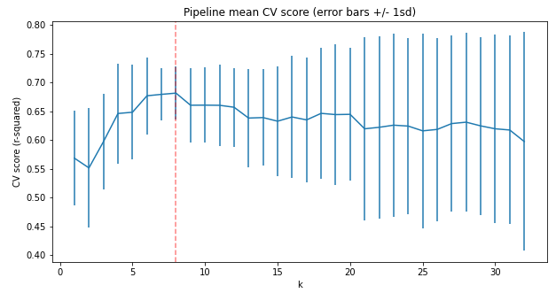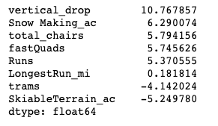

**Fig. G – Understanding the # of features to include in the model (SelectKBest technique) Fig. H – 8 Features and their Coefficients**

* For the second model, I used the Random Forest Regressor package
  + After completing the cross-validation step, the best model included features that weren’t scaled, imputed missing values with the median of each feature and used 69 random forest regressors
* Based on the Random Forest model, the most important features are shown below in **Fig. I**

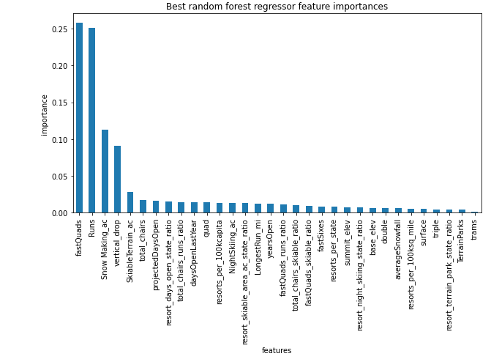

**Fig. I – Random Forest Feature Importance**

* When comparing the two models, the Random Forest Regressor was more accurate and also exhibited less variability
  + For the linear regression model, the MAE = $10.50 +- $1.62
  + For the random forest model, the MAE = $9.65 +- $1.35

*C4. Modelling Scenarios - Determining the true value for a Big Mountain Ski Lift Ticket 🡪*

* After running the random forest model on the test dataset, Big Mountain’s modelled price came out to $95.87
  + when compared to their current price of $81 and after accounting for an MAE of $10.39, the model implied that Big Mountain could possibly raise their ticket price without adversely affecting their current market share
* Does the modelled price make sense? Where does Big Mountain fit into the market landscape? Let’s see below

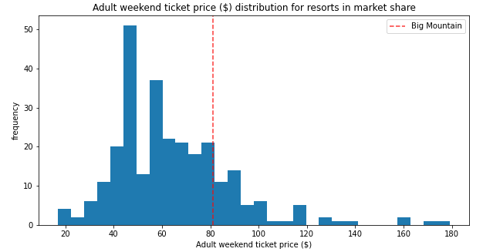 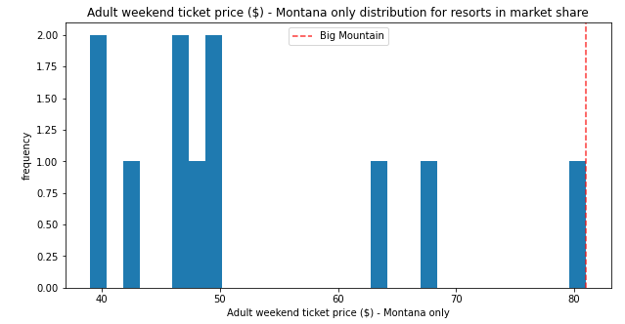

**Fig. J – Ticket Prices (All Resorts) Fig. K – Ticket Prices (Montana Resorts)**

* + Big Mountain is above the median ticket price when considering all resorts in the US and is also the most expensive in Montana

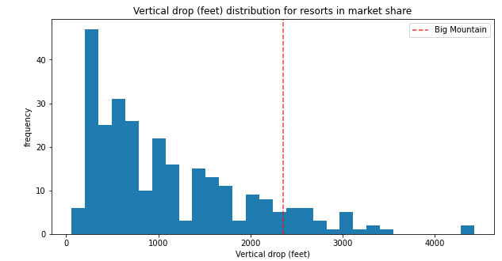 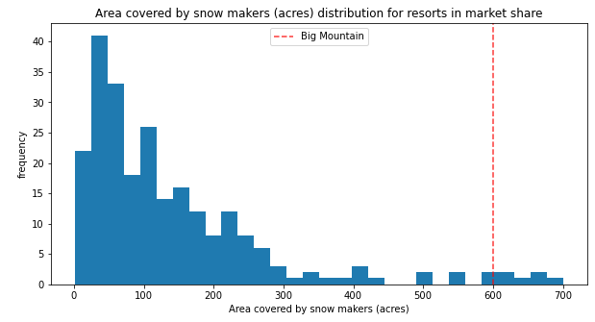

**Fig. L – Vertical Drop Fig. M – Snow Making Area**

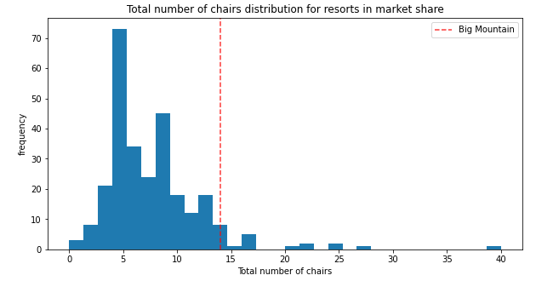 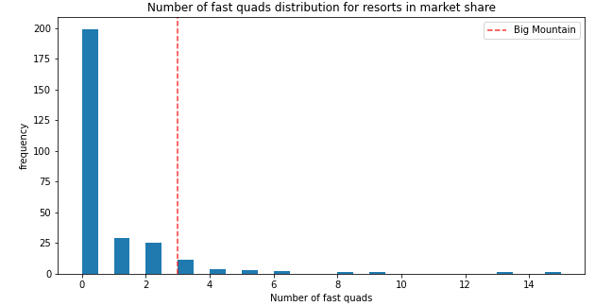

**Fig. N – # of Chairs Fig. O – # of Fast Quads**

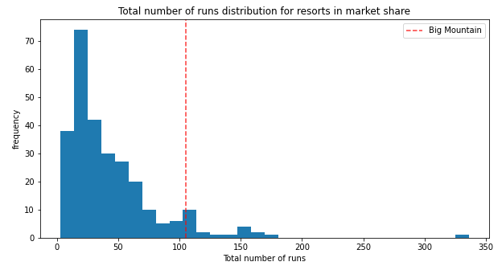 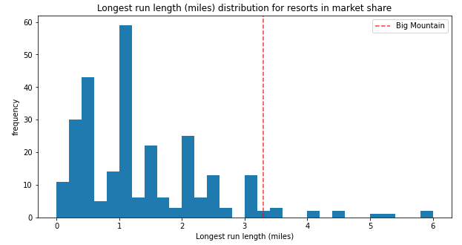

**Fig. P – # of Runs Fig. Q – Longest Run Length**

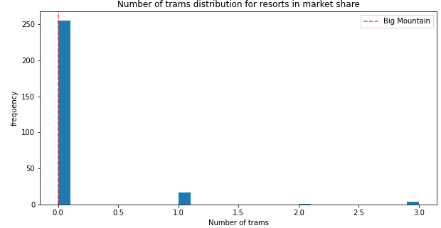 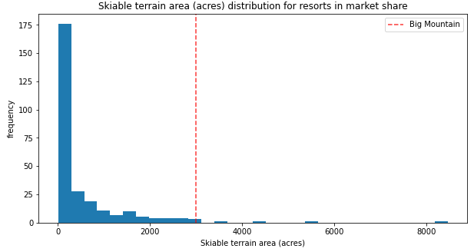

**Fig. R – # of Trams Fig. S – Total Skiable Terrain Area**

* Now, it makes sense to test out some scenarios; for each scenario, I used the assumption that Big Mountain expects 350,000 visitors this year
* Scenario 1 – Close up to 10 of the least used runs
  + As you will be able to see from the figures below, closing down 3 runs would result in a $.70 reduction in ticket price
  + Interestingly enough, closing down 1 run wouldn’t affect the ticket price per the model

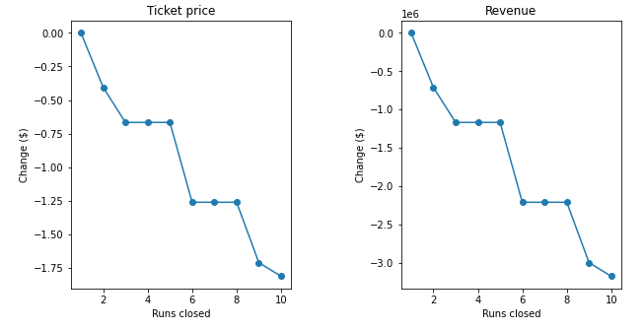

**Fig. T – Modeling Ticket Price based on # of Runs Closed**

* Scenario 2 – adding a run, increasing the vertical drop by 150 ft and installing an additional chair lift
  + After running the model, this scenario supported a ticket price increase of $1.99
* Scenario 3 – replication of scenario 2 + adding 2 acres of snow making
  + Again, the model suggests the resort could increase their ticket price by $1.99
* Scenario 4 – increasing the longest run by .2 miles + adding 4 acres of snow making capability
  + The model suggested that the ticket price remain the same

1. **Concluding Thoughts and Recommendations:**

* Based on the proposed model and scenarios, I believe that Big Mountain is underestimating their position in the marketplace by $5-10
* To better understand the decision to price the median ticket price at $81, I would need additional insight from the business and leadership team (operating parameters, immediate/regional competition, gross household income, etc.)
* At the very least, the model suggests that the leadership team should:
  + review their current operating parameters and general layout (e.g. what runs add the most value)
  + review their current pricing strategy
  + better understand their overall position in the market
  + create a pragmatic plan that supports ticket price appreciation